8.1: a)
b) (i) Five times the speed, 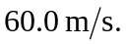(ii) 